**Performance & Analysis**





**The comparison of the Public Scores for all the model architectures considered for this data set is shown in Fig.**

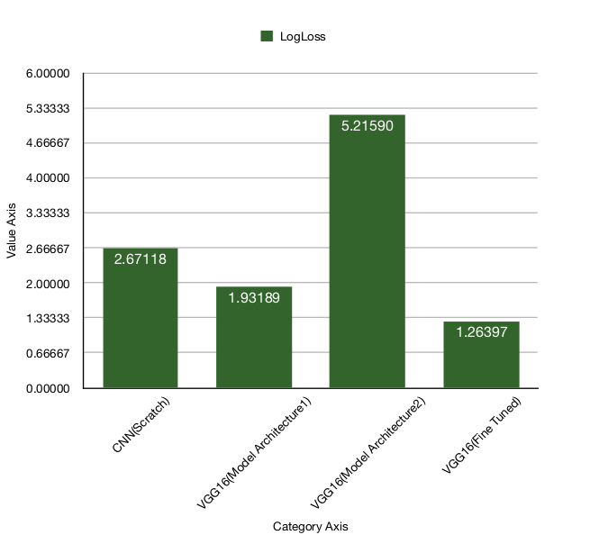

**From the given results and project models the accuracy of this file is 99.48% , precision is 99.49%, recall is 99.48% and F1 score is 99.48%.**